1.Brute force Geolocation map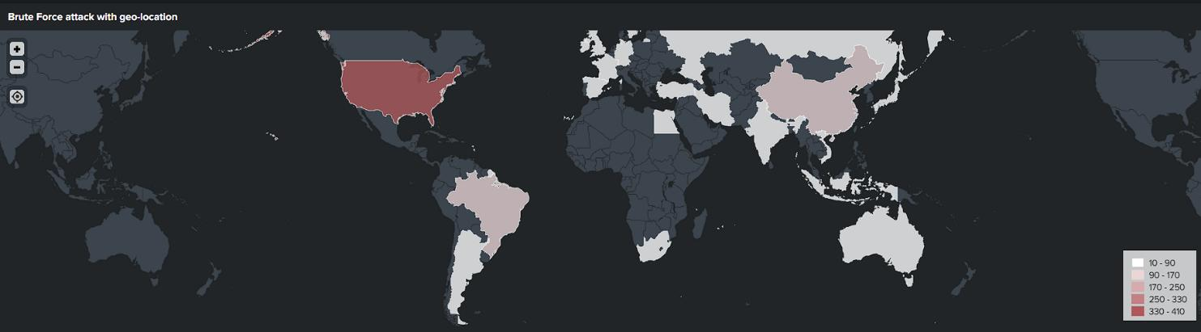
2.brute force ip address:

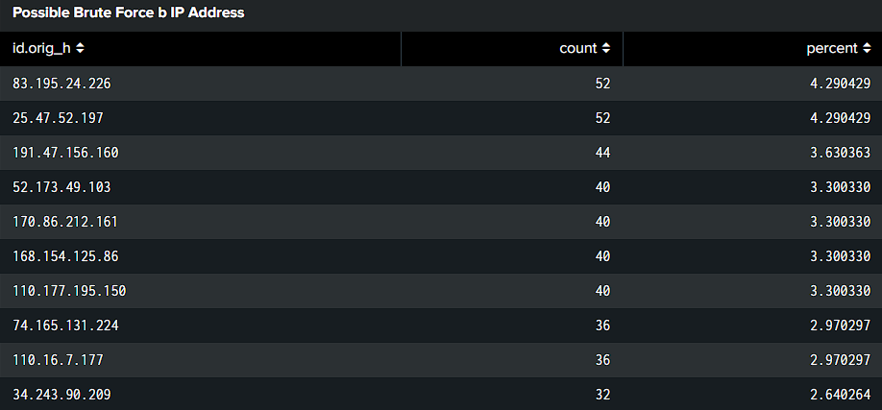
3. SSH Logs Dashboard: